Administrator@DESKTOP-QT517IN MINGW64 ~
$ pwd
/c/Users/Administrator

Administrator@DESKTOP-QT517IN MINGW64 ~
$ ls
'3D Objects'/
AppData/
'Application Data'@
Contacts/
Cookies@
Desktop/
Documents/
Downloads/
Favorites/
IntelGraphicsProfiles/
Links/
'Local Settings'@
Music/
'My Documents'@
NTUSER.DAT
NTUSER.DAT{53b39e88-18c4-11ea-a811-000d3aa4692b}.TM.blf
NTUSER.DAT{53b39e88-18c4-11ea-a811-000d3aa4692b}.TMContainer00000000000000000001.regtrans-ms
NTUSER.DAT{53b39e88-18c4-11ea-a811-000d3aa4692b}.TMContainer00000000000000000002.regtrans-ms
NetHood@
OneDrive/
Pictures/
PrintHood@
Recent@
'Saved Games'/
Searches/
SendTo@
'Start Menu'@
Templates@
'VS Class 1'/
Videos/
ntuser.dat.LOG1
ntuser.dat.LOG2
ntuser.ini

Administrator@DESKTOP-QT517IN MINGW64 ~
$ cd Documents/

Administrator@DESKTOP-QT517IN MINGW64 ~/Documents
$ ls
'Custom Office Templates'/ 'My Music'@ 'My Pictures'@ 'My Videos'@ school/ ssh/ user1/ user2/ zarrar/

Administrator@DESKTOP-QT517IN MINGW64 ~/Documents
$ ls
Admin1/ 'Custom Office Templates'/ 'My Music'@ 'My Pictures'@ 'My Videos'@ school/ ssh/ user1/ user2/ zarrar/

Administrator@DESKTOP-QT517IN MINGW64 ~/Documents
$ ls
Conflict/ 'Custom Office Templates'/ 'My Music'@ 'My Pictures'@ 'My Videos'@ school/ ssh/ zarrar/

Administrator@DESKTOP-QT517IN MINGW64 ~/Documents
$ cd Conflict/

Administrator@DESKTOP-QT517IN MINGW64 ~/Documents/Conflict
$ ls
Admin1/ user1/ user2/

Administrator@DESKTOP-QT517IN MINGW64 ~/Documents/Conflict
$ cd Admin1/

Administrator@DESKTOP-QT517IN MINGW64 ~/Documents/Conflict/Admin1
$ touch mussadiq.css index.html ppp.php

Administrator@DESKTOP-QT517IN MINGW64 ~/Documents/Conflict/Admin1
$ git init
Initialized empty Git repository in C:/Users/Administrator/Documents/Conflict/Admin1/.git/

Administrator@DESKTOP-QT517IN MINGW64 ~/Documents/Conflict/Admin1 (master)
$ git status
On branch master

No commits yet

Untracked files:
(use "git add <file>..." to include in what will be committed)
index.html
mussadiq.css
ppp.php

nothing added to commit but untracked files present (use "git add" to track)

Administrator@DESKTOP-QT517IN MINGW64 ~/Documents/Conflict/Admin1 (master)
$ git add .

Administrator@DESKTOP-QT517IN MINGW64 ~/Documents/Conflict/Admin1 (master)
$ git status
On branch master

No commits yet

Changes to be committed:
(use "git rm --cached <file>..." to unstage)
new file: index.html
new file: mussadiq.css
new file: ppp.php

Administrator@DESKTOP-QT517IN MINGW64 ~/Documents/Conflict/Admin1 (master)
$ git commit -m 'added index.html mussadiq.css ppp.php'
[master (root-commit) 7e62e41] added index.html mussadiq.css ppp.php
3 files changed, 0 insertions(+), 0 deletions(-)
create mode 100644 index.html
create mode 100644 mussadiq.css
create mode 100644 ppp.php

Administrator@DESKTOP-QT517IN MINGW64 ~/Documents/Conflict/Admin1 (master)
$ git remote origin https://github.com/plato45/conflict.git
error: unknown subcommand: `origin'
usage: git remote [-v | --verbose]
or: git remote add [-t <branch>] [-m <master>] [-f] [--tags | --no-tags] [--mirror=<fetch|push>] <name> <url>
or: git remote rename [--[no-]progress] <old> <new>
or: git remote remove <name>
or: git remote set-head <name> (-a | --auto | -d | --delete | <branch>)
or: git remote [-v | --verbose] show [-n] <name>
or: git remote prune [-n | --dry-run] <name>
or: git remote [-v | --verbose] update [-p | --prune] [(<group> | <remote>)...]
or: git remote set-branches [--add] <name> <branch>...
or: git remote get-url [--push] [--all] <name>
or: git remote set-url [--push] <name> <newurl> [<oldurl>]
or: git remote set-url --add <name> <newurl>
or: git remote set-url --delete <name> <url>

-v, --verbose be verbose; must be placed before a subcommand

Administrator@DESKTOP-QT517IN MINGW64 ~/Documents/Conflict/Admin1 (master)
$ git remote add origin https://github.com/plato45/conflict.git

Administrator@DESKTOP-QT517IN MINGW64 ~/Documents/Conflict/Admin1 (master)
$ git remote origin master
error: unknown subcommand: `origin'
usage: git remote [-v | --verbose]
or: git remote add [-t <branch>] [-m <master>] [-f] [--tags | --no-tags] [--mirror=<fetch|push>] <name> <url>
or: git remote rename [--[no-]progress] <old> <new>
or: git remote remove <name>
or: git remote set-head <name> (-a | --auto | -d | --delete | <branch>)
or: git remote [-v | --verbose] show [-n] <name>
or: git remote prune [-n | --dry-run] <name>
or: git remote [-v | --verbose] update [-p | --prune] [(<group> | <remote>)...]
or: git remote set-branches [--add] <name> <branch>...
or: git remote get-url [--push] [--all] <name>
or: git remote set-url [--push] <name> <newurl> [<oldurl>]
or: git remote set-url --add <name> <newurl>
or: git remote set-url --delete <name> <url>

-v, --verbose be verbose; must be placed before a subcommand

Administrator@DESKTOP-QT517IN MINGW64 ~/Documents/Conflict/Admin1 (master)
$ git remote add origin https://github.com/plato45/conflict.git
error: remote origin already exists.

Administrator@DESKTOP-QT517IN MINGW64 ~/Documents/Conflict/Admin1 (master)
$ git push origin master
Enumerating objects: 3, done.
Counting objects: 100% (3/3), done.
Delta compression using up to 4 threads
Compressing objects: 100% (2/2), done.
Writing objects: 100% (3/3), 255 bytes | 255.00 KiB/s, done.
Total 3 (delta 0), reused 0 (delta 0), pack-reused 0
To https://github.com/plato45/conflict.git
* [new branch] master -> master

Administrator@DESKTOP-QT517IN MINGW64 ~/Documents/Conflict/Admin1 (master)
$ ls
index.html mussadiq.css ppp.php

Administrator@DESKTOP-QT517IN MINGW64 ~/Documents/Conflict/Admin1 (master)
$ rm -rf index.html ppp.php

Administrator@DESKTOP-QT517IN MINGW64 ~/Documents/Conflict/Admin1 (master)
$ ls
mussadiq.css

Administrator@DESKTOP-QT517IN MINGW64 ~/Documents/Conflict/Admin1 (master)
$ git remote add origi https://github.com/plato45/code.git

Administrator@DESKTOP-QT517IN MINGW64 ~/Documents/Conflict/Admin1 (master)
$ git push origin master
remote: Repository not found.
fatal: repository 'https://github.com/plato45/conflict.git/' not found

Administrator@DESKTOP-QT517IN MINGW64 ~/Documents/Conflict/Admin1 (master)
$ git remote add origin Repository not found.
fatal: repository 'https://github.com/plato45/conflict.git/' not found
usage: git remote add [<options>] <name> <url>

-f, --fetch fetch the remote branches
--tags import all tags and associated objects when fetching
or do not fetch any tag at all (--no-tags)
-t, --track <branch> branch(es) to track
-m, --master <branch>
master branch
--mirror[=(push|fetch)]
set up remote as a mirror to push to or fetch from

bash: fatal:: command not found

Administrator@DESKTOP-QT517IN MINGW64 ~/Documents/Conflict/Admin1 (master)
$ git remote add origin https://github.com/plato45/code.git
error: remote origin already exists.

Administrator@DESKTOP-QT517IN MINGW64 ~/Documents/Conflict/Admin1 (master)
$ git push origin master
remote: Repository not found.
fatal: repository 'https://github.com/plato45/conflict.git/' not found

Administrator@DESKTOP-QT517IN MINGW64 ~/Documents/Conflict/Admin1 (master)
$ cd ..

Administrator@DESKTOP-QT517IN MINGW64 ~/Documents/Conflict
$ ls
Admin1/ user1/ user2/

Administrator@DESKTOP-QT517IN MINGW64 ~/Documents/Conflict
$ cd Admin1/

Administrator@DESKTOP-QT517IN MINGW64 ~/Documents/Conflict/Admin1 (master)
$ ls
mussadiq.css

Administrator@DESKTOP-QT517IN MINGW64 ~/Documents/Conflict/Admin1 (master)
$ cd ..

Administrator@DESKTOP-QT517IN MINGW64 ~/Documents/Conflict
$ ls
Admin1/ user1/ user2/

Administrator@DESKTOP-QT517IN MINGW64 ~/Documents/Conflict
$ rm -rf Admin1/user2 user1/

Administrator@DESKTOP-QT517IN MINGW64 ~/Documents/Conflict
$ ls
Admin1/ user2/

Administrator@DESKTOP-QT517IN MINGW64 ~/Documents/Conflict
$ rm -rf Admin1/

Administrator@DESKTOP-QT517IN MINGW64 ~/Documents/Conflict
$ ls
user2/

Administrator@DESKTOP-QT517IN MINGW64 ~/Documents/Conflict
$ rm -rf user2/

Administrator@DESKTOP-QT517IN MINGW64 ~/Documents/Conflict
$ ls

Administrator@DESKTOP-QT517IN MINGW64 ~/Documents/Conflict
$ mkdir admin user1 user2

Administrator@DESKTOP-QT517IN MINGW64 ~/Documents/Conflict
$ ls
admin/ user1/ user2/

Administrator@DESKTOP-QT517IN MINGW64 ~/Documents/Conflict
$ cd admin

Administrator@DESKTOP-QT517IN MINGW64 ~/Documents/Conflict/admin
$ git init
Initialized empty Git repository in C:/Users/Administrator/Documents/Conflict/admin/.git/

Administrator@DESKTOP-QT517IN MINGW64 ~/Documents/Conflict/admin (master)
$ touch mussadiq.php

Administrator@DESKTOP-QT517IN MINGW64 ~/Documents/Conflict/admin (master)
$ ls
mussadiq.php

Administrator@DESKTOP-QT517IN MINGW64 ~/Documents/Conflict/admin (master)
$ git remote add origin https://github.com/plato45/code.git

Administrator@DESKTOP-QT517IN MINGW64 ~/Documents/Conflict/admin (master)
$ git push origin master
error: src refspec master does not match any
error: failed to push some refs to 'https://github.com/plato45/code.git'

Administrator@DESKTOP-QT517IN MINGW64 ~/Documents/Conflict/admin (master)
$ git status
On branch master

No commits yet

Untracked files:
(use "git add <file>..." to include in what will be committed)
mussadiq.php

nothing added to commit but untracked files present (use "git add" to track)

Administrator@DESKTOP-QT517IN MINGW64 ~/Documents/Conflict/admin (master)
$ git add .

Administrator@DESKTOP-QT517IN MINGW64 ~/Documents/Conflict/admin (master)
$ git commit -m'added mussadiq.php'
[master (root-commit) a447872] added mussadiq.php
1 file changed, 0 insertions(+), 0 deletions(-)
create mode 100644 mussadiq.php

Administrator@DESKTOP-QT517IN MINGW64 ~/Documents/Conflict/admin (master)
$ git status
On branch master
nothing to commit, working tree clean

Administrator@DESKTOP-QT517IN MINGW64 ~/Documents/Conflict/admin (master)
$ git remote add origin https://github.com/plato45/code.git
error: remote origin already exists.

Administrator@DESKTOP-QT517IN MINGW64 ~/Documents/Conflict/admin (master)
$ git push origin master
Enumerating objects: 3, done.
Counting objects: 100% (3/3), done.
Writing objects: 100% (3/3), 217 bytes | 217.00 KiB/s, done.
Total 3 (delta 0), reused 0 (delta 0), pack-reused 0
To https://github.com/plato45/code.git
* [new branch] master -> master

Administrator@DESKTOP-QT517IN MINGW64 ~/Documents/Conflict/admin (master)
$ cd ..

Administrator@DESKTOP-QT517IN MINGW64 ~/Documents/Conflict
$ ls
admin/ user1/ user2/

Administrator@DESKTOP-QT517IN MINGW64 ~/Documents/Conflict
$ cd user1

Administrator@DESKTOP-QT517IN MINGW64 ~/Documents/Conflict/user1
$ ls

Administrator@DESKTOP-QT517IN MINGW64 ~/Documents/Conflict/user1
$ git clone https://github.com/plato45/code.git
Cloning into 'code'...
remote: Enumerating objects: 3, done.
remote: Counting objects: 100% (3/3), done.
remote: Total 3 (delta 0), reused 3 (delta 0), pack-reused 0
Receiving objects: 100% (3/3), done.

Administrator@DESKTOP-QT517IN MINGW64 ~/Documents/Conflict/user1
$ cd ..

Administrator@DESKTOP-QT517IN MINGW64 ~/Documents/Conflict
$ ls
admin/ user1/ user2/

Administrator@DESKTOP-QT517IN MINGW64 ~/Documents/Conflict
$ cd user2

Administrator@DESKTOP-QT517IN MINGW64 ~/Documents/Conflict/user2
$ git clone https://github.com/plato45/code.git
Cloning into 'code'...
remote: Enumerating objects: 3, done.
remote: Counting objects: 100% (3/3), done.
remote: Total 3 (delta 0), reused 3 (delta 0), pack-reused 0
Receiving objects: 100% (3/3), done.

Administrator@DESKTOP-QT517IN MINGW64 ~/Documents/Conflict/user2
$ cd ..

Administrator@DESKTOP-QT517IN MINGW64 ~/Documents/Conflict
$ ls
admin/ user1/ user2/

Administrator@DESKTOP-QT517IN MINGW64 ~/Documents/Conflict
$ cd user1

Administrator@DESKTOP-QT517IN MINGW64 ~/Documents/Conflict/user1
$ git branch
fatal: not a git repository (or any of the parent directories): .git

Administrator@DESKTOP-QT517IN MINGW64 ~/Documents/Conflict/user1
$ git branch mussadiq
fatal: not a git repository (or any of the parent directories): .git

Administrator@DESKTOP-QT517IN MINGW64 ~/Documents/Conflict/user1
$ git checkout
fatal: not a git repository (or any of the parent directories): .git

Administrator@DESKTOP-QT517IN MINGW64 ~/Documents/Conflict/user1
$ ls
code/

Administrator@DESKTOP-QT517IN MINGW64 ~/Documents/Conflict/user1
$ cd code

Administrator@DESKTOP-QT517IN MINGW64 ~/Documents/Conflict/user1/code (master)
$ ls
mussadiq.php

Administrator@DESKTOP-QT517IN MINGW64 ~/Documents/Conflict/user1/code (master)
$ git branch amir

Administrator@DESKTOP-QT517IN MINGW64 ~/Documents/Conflict/user1/code (master)
$ git git branch
git: 'git' is not a git command. See 'git --help'.

The most similar command is
init

Administrator@DESKTOP-QT517IN MINGW64 ~/Documents/Conflict/user1/code (master)
$ git branch
amir
* master

Administrator@DESKTOP-QT517IN MINGW64 ~/Documents/Conflict/user1/code (master)
$ git checkout namir
error: pathspec 'namir' did not match any file(s) known to git

Administrator@DESKTOP-QT517IN MINGW64 ~/Documents/Conflict/user1/code (master)
$ git branch amir
fatal: a branch named 'amir' already exists

Administrator@DESKTOP-QT517IN MINGW64 ~/Documents/Conflict/user1/code (master)
$ git branch
amir
* master

Administrator@DESKTOP-QT517IN MINGW64 ~/Documents/Conflict/user1/code (master)
$ git checkout amir
Switched to branch 'amir'

Administrator@DESKTOP-QT517IN MINGW64 ~/Documents/Conflict/user1/code (amir)
$ git branch
* amir
master

Administrator@DESKTOP-QT517IN MINGW64 ~/Documents/Conflict/user1/code (amir)
$ ls
mussadiq.php

Administrator@DESKTOP-QT517IN MINGW64 ~/Documents/Conflict/user1/code (amir)
$ code mussadiq.php

Administrator@DESKTOP-QT517IN MINGW64 ~/Documents/Conflict/user1/code (amir)
$ ls
mussadiq.php

Administrator@DESKTOP-QT517IN MINGW64 ~/Documents/Conflict/user1/code (amir)
$ git push origin amir
Total 0 (delta 0), reused 0 (delta 0), pack-reused 0
remote:
remote: Create a pull request for 'amir' on GitHub by visiting:
remote: https://github.com/plato45/code/pull/new/amir
remote:
To https://github.com/plato45/code.git
* [new branch] amir -> amir

Administrator@DESKTOP-QT517IN MINGW64 ~/Documents/Conflict/user1/code (amir)
$ git status
On branch amir
Changes not staged for commit:
(use "git add <file>..." to update what will be committed)
(use "git restore <file>..." to discard changes in working directory)
modified: mussadiq.php

no changes added to commit (use "git add" and/or "git commit -a")

Administrator@DESKTOP-QT517IN MINGW64 ~/Documents/Conflict/user1/code (amir)
$ git add .

Administrator@DESKTOP-QT517IN MINGW64 ~/Documents/Conflict/user1/code (amir)
$ git commit -m '
> '
Aborting commit due to empty commit message.

Administrator@DESKTOP-QT517IN MINGW64 ~/Documents/Conflict/user1/code (amir)
$ git commit -m'mussadiq.php'
[amir 67f6d13] mussadiq.php
1 file changed, 13 insertions(+)

Administrator@DESKTOP-QT517IN MINGW64 ~/Documents/Conflict/user1/code (amir)
$ git push origin amir
Enumerating objects: 5, done.
Counting objects: 100% (5/5), done.
Delta compression using up to 4 threads
Compressing objects: 100% (2/2), done.
Writing objects: 100% (3/3), 443 bytes | 443.00 KiB/s, done.
Total 3 (delta 0), reused 0 (delta 0), pack-reused 0
To https://github.com/plato45/code.git
a447872..67f6d13 amir -> amir

Administrator@DESKTOP-QT517IN MINGW64 ~/Documents/Conflict/user1/code (amir)
$ cd ..

Administrator@DESKTOP-QT517IN MINGW64 ~/Documents/Conflict/user1
$ ls
code/

Administrator@DESKTOP-QT517IN MINGW64 ~/Documents/Conflict/user1
$ git checkout master
fatal: not a git repository (or any of the parent directories): .git

Administrator@DESKTOP-QT517IN MINGW64 ~/Documents/Conflict/user1
$ ls
code/

Administrator@DESKTOP-QT517IN MINGW64 ~/Documents/Conflict/user1
$ git branch
fatal: not a git repository (or any of the parent directories): .git

Administrator@DESKTOP-QT517IN MINGW64 ~/Documents/Conflict/user1
$ git branch
fatal: not a git repository (or any of the parent directories): .git

Administrator@DESKTOP-QT517IN MINGW64 ~/Documents/Conflict/user1
$ cd code

Administrator@DESKTOP-QT517IN MINGW64 ~/Documents/Conflict/user1/code (amir)
$ git branch
* amir
master

Administrator@DESKTOP-QT517IN MINGW64 ~/Documents/Conflict/user1/code (amir)
$ git branch master
fatal: a branch named 'master' already exists

Administrator@DESKTOP-QT517IN MINGW64 ~/Documents/Conflict/user1/code (amir)
$ git checkout master
Switched to branch 'master'
Your branch is up to date with 'origin/master'.

Administrator@DESKTOP-QT517IN MINGW64 ~/Documents/Conflict/user1/code (master)
$ git branch
amir
* master

Administrator@DESKTOP-QT517IN MINGW64 ~/Documents/Conflict/user1/code (master)
$ cd ..

Administrator@DESKTOP-QT517IN MINGW64 ~/Documents/Conflict/user1
$ ls
code/

Administrator@DESKTOP-QT517IN MINGW64 ~/Documents/Conflict/user1
$ cd ..

Administrator@DESKTOP-QT517IN MINGW64 ~/Documents/Conflict
$ ls
admin/ user1/ user2/

Administrator@DESKTOP-QT517IN MINGW64 ~/Documents/Conflict
$ cd user2

Administrator@DESKTOP-QT517IN MINGW64 ~/Documents/Conflict/user2
$ ls
code/

Administrator@DESKTOP-QT517IN MINGW64 ~/Documents/Conflict/user2
$ cd code

Administrator@DESKTOP-QT517IN MINGW64 ~/Documents/Conflict/user2/code (master)
$ ls
mussadiq.php

Administrator@DESKTOP-QT517IN MINGW64 ~/Documents/Conflict/user2/code (master)
$ git status
On branch master
Your branch is up to date with 'origin/master'.

nothing to commit, working tree clean

Administrator@DESKTOP-QT517IN MINGW64 ~/Documents/Conflict/user2/code (master)
$ code mussadiq.php

Administrator@DESKTOP-QT517IN MINGW64 ~/Documents/Conflict/user2/code (master)
$ git status
On branch master
Your branch is up to date with 'origin/master'.

Changes not staged for commit:
(use "git add <file>..." to update what will be committed)
(use "git restore <file>..." to discard changes in working directory)
modified: mussadiq.php

no changes added to commit (use "git add" and/or "git commit -a")

Administrator@DESKTOP-QT517IN MINGW64 ~/Documents/Conflict/user2/code (master)
$ git add .

Administrator@DESKTOP-QT517IN MINGW64 ~/Documents/Conflict/user2/code (master)
$ git commit -m 'mussadiq.php'
[master 474eaad] mussadiq.php
1 file changed, 12 insertions(+)

Administrator@DESKTOP-QT517IN MINGW64 ~/Documents/Conflict/user2/code (master)
$ git status
On branch master
Your branch is ahead of 'origin/master' by 1 commit.
(use "git push" to publish your local commits)

nothing to commit, working tree clean

Administrator@DESKTOP-QT517IN MINGW64 ~/Documents/Conflict/user2/code (master)
$ git branch
* master

Administrator@DESKTOP-QT517IN MINGW64 ~/Documents/Conflict/user2/code (master)
$ git branch ghani

Administrator@DESKTOP-QT517IN MINGW64 ~/Documents/Conflict/user2/code (master)
$ git branch
ghani
* master

Administrator@DESKTOP-QT517IN MINGW64 ~/Documents/Conflict/user2/code (master)
$ git checkout ghani
Switched to branch 'ghani'

Administrator@DESKTOP-QT517IN MINGW64 ~/Documents/Conflict/user2/code (ghani)
$ git status
On branch ghani
nothing to commit, working tree clean

Administrator@DESKTOP-QT517IN MINGW64 ~/Documents/Conflict/user2/code (ghani)
$ git branch
* ghani
master

Administrator@DESKTOP-QT517IN MINGW64 ~/Documents/Conflict/user2/code (ghani)
$ ls
mussadiq.php

Administrator@DESKTOP-QT517IN MINGW64 ~/Documents/Conflict/user2/code (ghani)
$ git push origin ghani
Enumerating objects: 5, done.
Counting objects: 100% (5/5), done.
Delta compression using up to 4 threads
Compressing objects: 100% (2/2), done.
Writing objects: 100% (3/3), 439 bytes | 439.00 KiB/s, done.
Total 3 (delta 0), reused 0 (delta 0), pack-reused 0
remote:
remote: Create a pull request for 'ghani' on GitHub by visiting:
remote: https://github.com/plato45/code/pull/new/ghani
remote:
To https://github.com/plato45/code.git
* [new branch] ghani -> ghani

Administrator@DESKTOP-QT517IN MINGW64 ~/Documents/Conflict/user2/code (ghani)
$ cd ..

Administrator@DESKTOP-QT517IN MINGW64 ~/Documents/Conflict/user2
$ cd ..

Administrator@DESKTOP-QT517IN MINGW64 ~/Documents/Conflict
$ ls
admin/ user1/ user2/

Administrator@DESKTOP-QT517IN MINGW64 ~/Documents/Conflict
$ cd admin/

Administrator@DESKTOP-QT517IN MINGW64 ~/Documents/Conflict/admin (master)
$ ls
mussadiq.php

Administrator@DESKTOP-QT517IN MINGW64 ~/Documents/Conflict/admin (master)
$ code mussadiq.php

Administrator@DESKTOP-QT517IN MINGW64 ~/Documents/Conflict/admin (master)
$ git pull origin ghani
remote: Enumerating objects: 5, done.
remote: Counting objects: 100% (5/5), done.
remote: Compressing objects: 100% (2/2), done.
remote: Total 3 (delta 0), reused 3 (delta 0), pack-reused 0
Unpacking objects: 100% (3/3), 419 bytes | 23.00 KiB/s, done.
From https://github.com/plato45/code
* branch ghani -> FETCH_HEAD
* [new branch] ghani -> origin/ghani
Updating a447872..474eaad
Fast-forward
mussadiq.php | 12 ++++++++++++
1 file changed, 12 insertions(+)

Administrator@DESKTOP-QT517IN MINGW64 ~/Documents/Conflict/admin (master)
$ git pull origin amir
remote: Enumerating objects: 5, done.
remote: Counting objects: 100% (5/5), done.
remote: Compressing objects: 100% (2/2), done.
remote: Total 3 (delta 0), reused 3 (delta 0), pack-reused 0
Unpacking objects: 100% (3/3), 423 bytes | 20.00 KiB/s, done.
From https://github.com/plato45/code
* branch amir -> FETCH_HEAD
* [new branch] amir -> origin/amir
Auto-merging mussadiq.php
CONFLICT (content): Merge conflict in mussadiq.php
Automatic merge failed; fix conflicts and then commit the result.

Administrator@DESKTOP-QT517IN MINGW64 ~/Documents/Conflict/admin (master|MERGING)
$ git push origin master
Total 0 (delta 0), reused 0 (delta 0), pack-reused 0
To https://github.com/plato45/code.git
a447872..474eaad master -> master

Administrator@DESKTOP-QT517IN MINGW64 ~/Documents/Conflict/admin (master|MERGING)
$ code mussadiq.php

Administrator@DESKTOP-QT517IN MINGW64 ~/Documents/Conflict/admin (master|MERGING)
$ git status
On branch master
You have unmerged paths.
(fix conflicts and run "git commit")
(use "git merge --abort" to abort the merge)

Unmerged paths:
(use "git add <file>..." to mark resolution)
both modified: mussadiq.php

no changes added to commit (use "git add" and/or "git commit -a")

Administrator@DESKTOP-QT517IN MINGW64 ~/Documents/Conflict/admin (master|MERGING)
$ git add .

Administrator@DESKTOP-QT517IN MINGW64 ~/Documents/Conflict/admin (master|MERGING)
$ git commit -m 'both modified mussadiq.php'
[master 7bca88c] both modified mussadiq.php

Administrator@DESKTOP-QT517IN MINGW64 ~/Documents/Conflict/admin (master)
$ git push origin master
Enumerating objects: 7, done.
Counting objects: 100% (7/7), done.
Delta compression using up to 4 threads
Compressing objects: 100% (2/2), done.
Writing objects: 100% (3/3), 351 bytes | 351.00 KiB/s, done.
Total 3 (delta 1), reused 0 (delta 0), pack-reused 0
remote: Resolving deltas: 100% (1/1), completed with 1 local object.
To https://github.com/plato45/code.git
474eaad..7bca88c master -> master

Administrator@DESKTOP-QT517IN MINGW64 ~/Documents/Conflict/admin (master)
$ ^C

Administrator@DESKTOP-QT517IN MINGW64 ~/Documents/Conflict/admin (master)
$
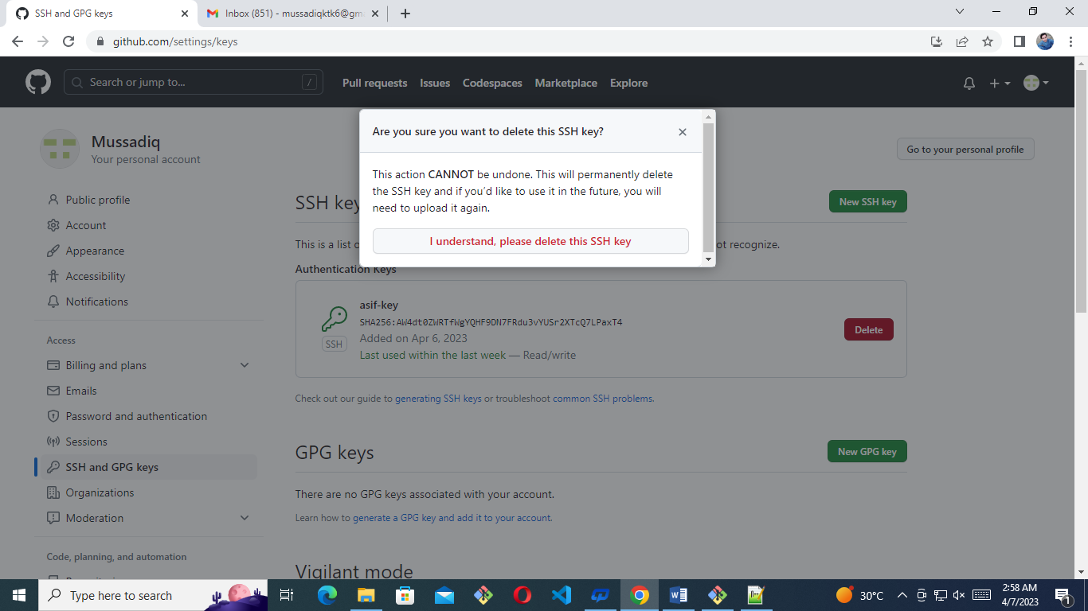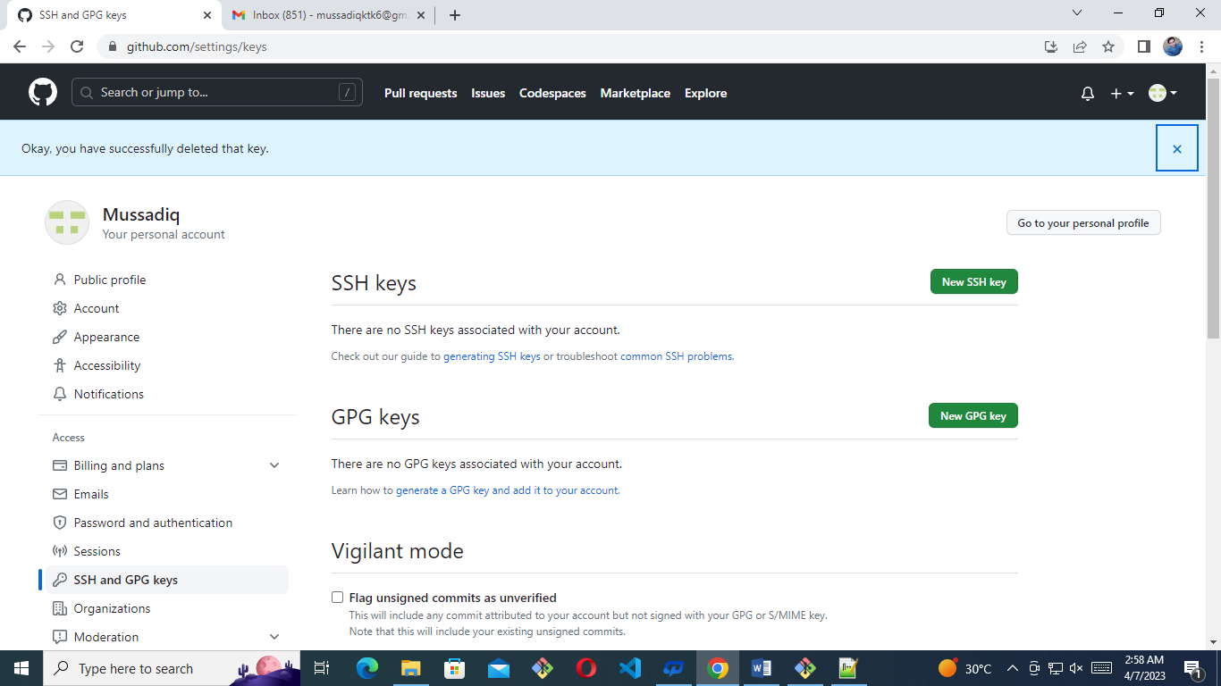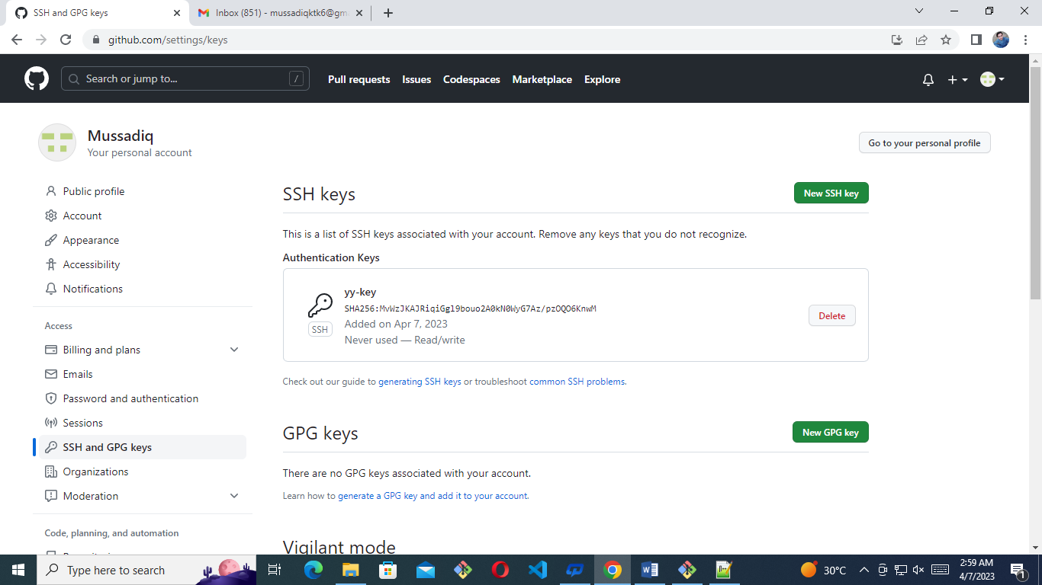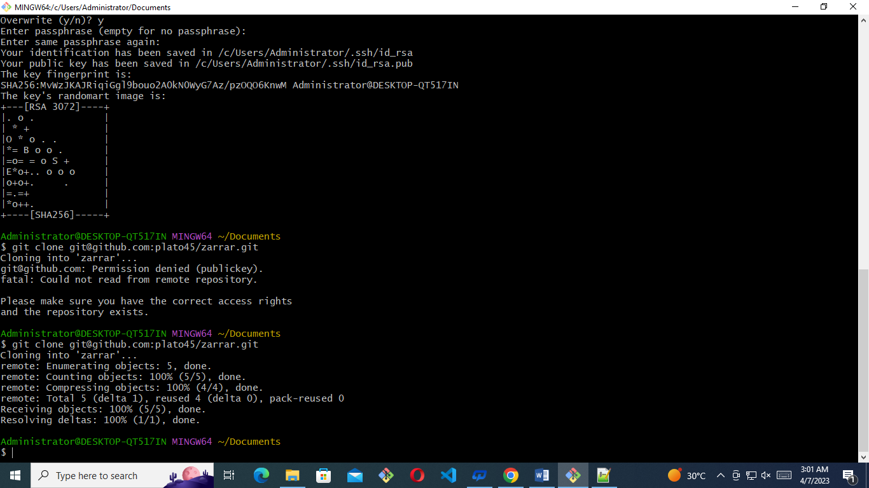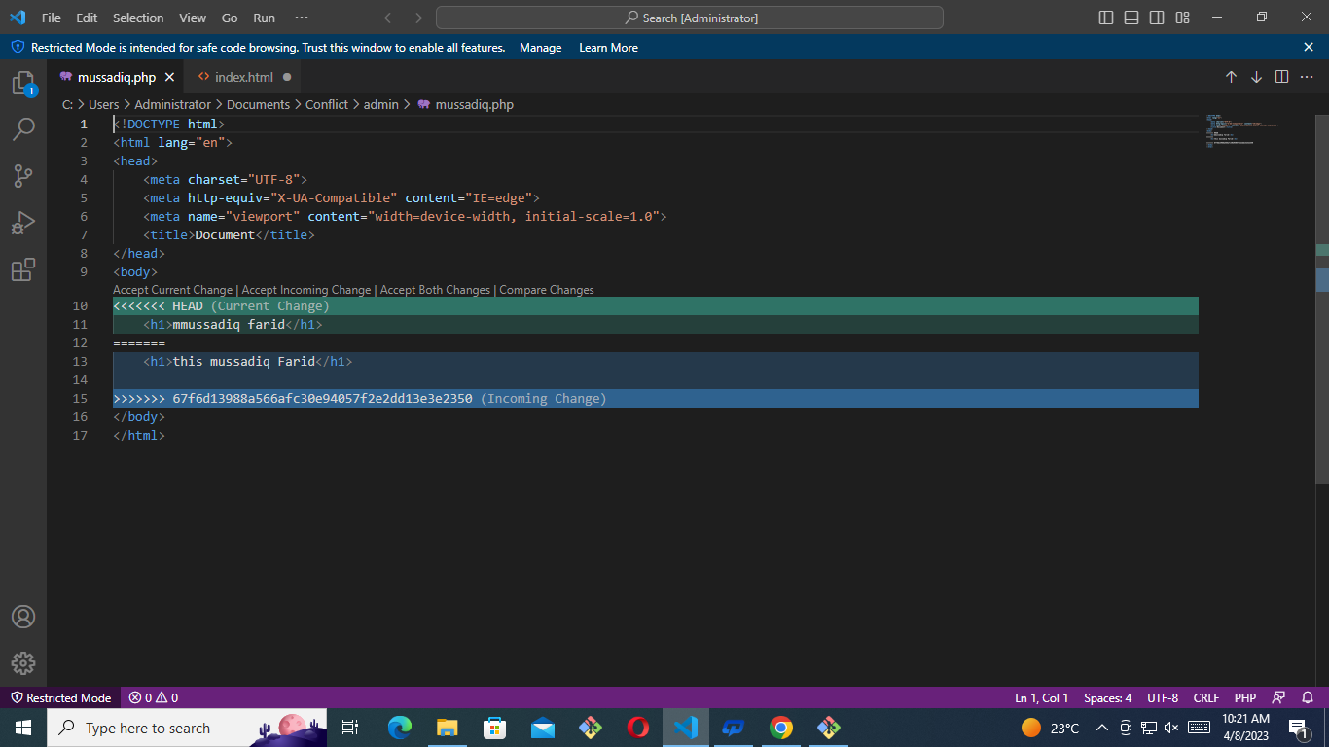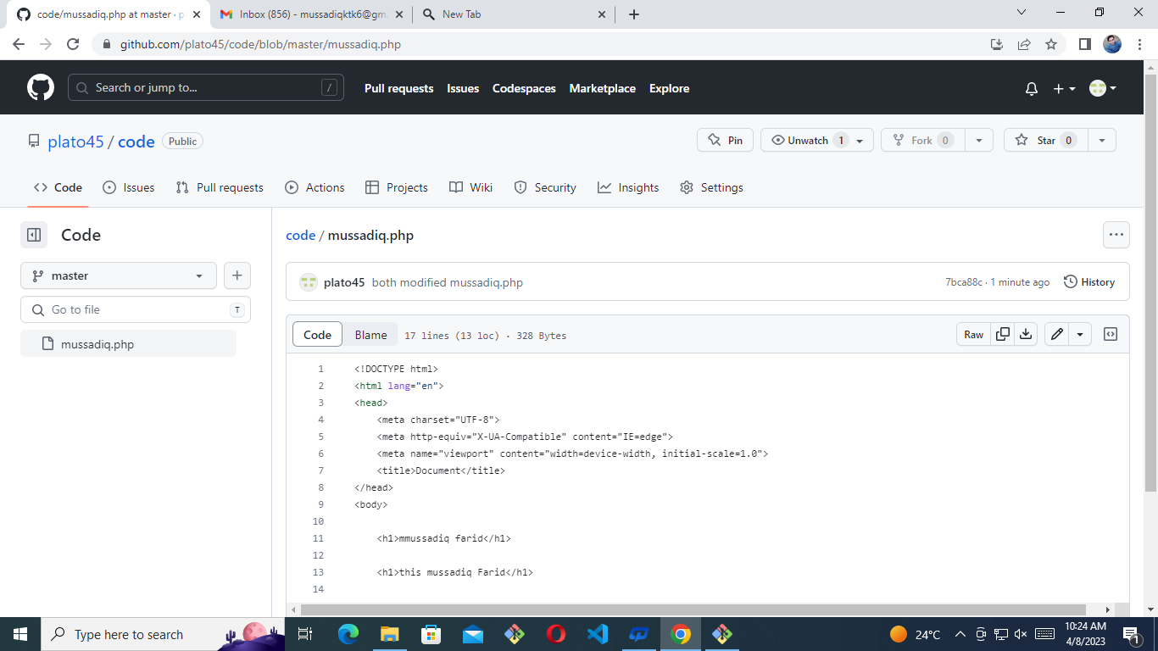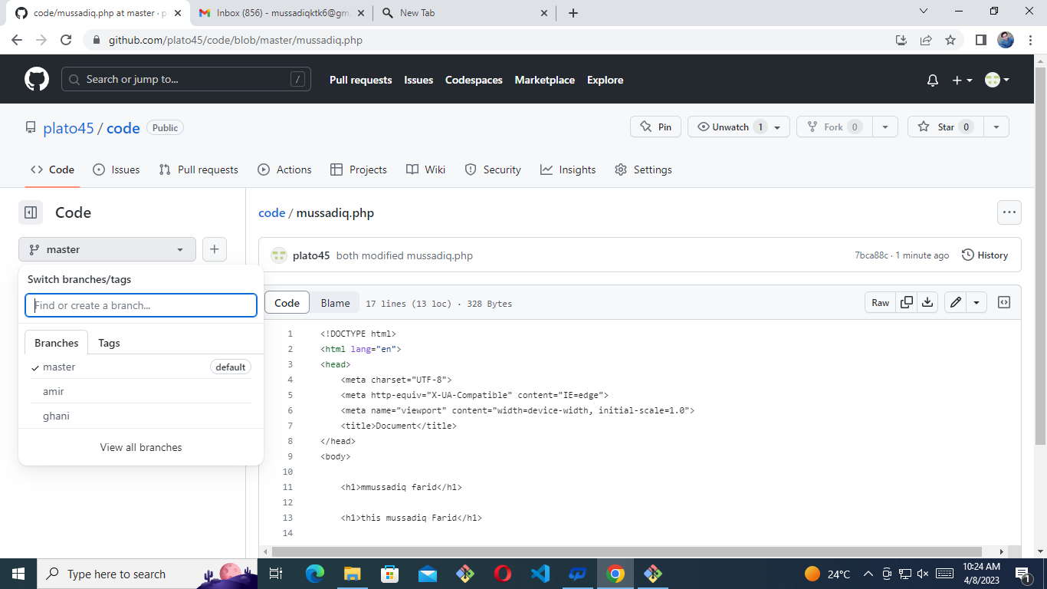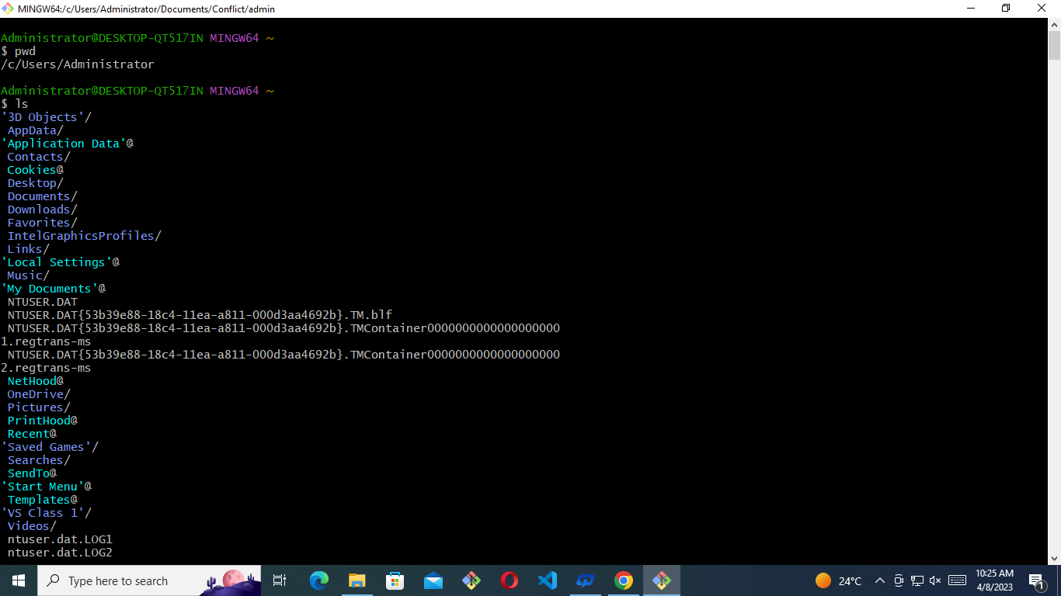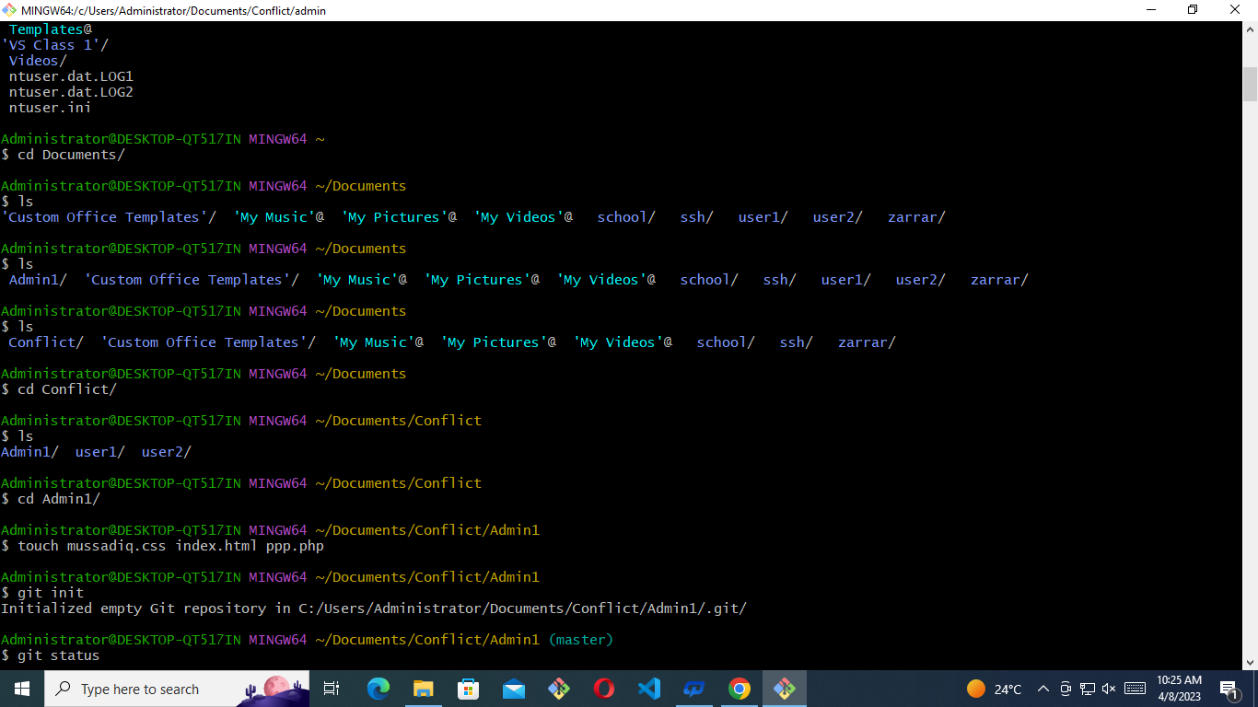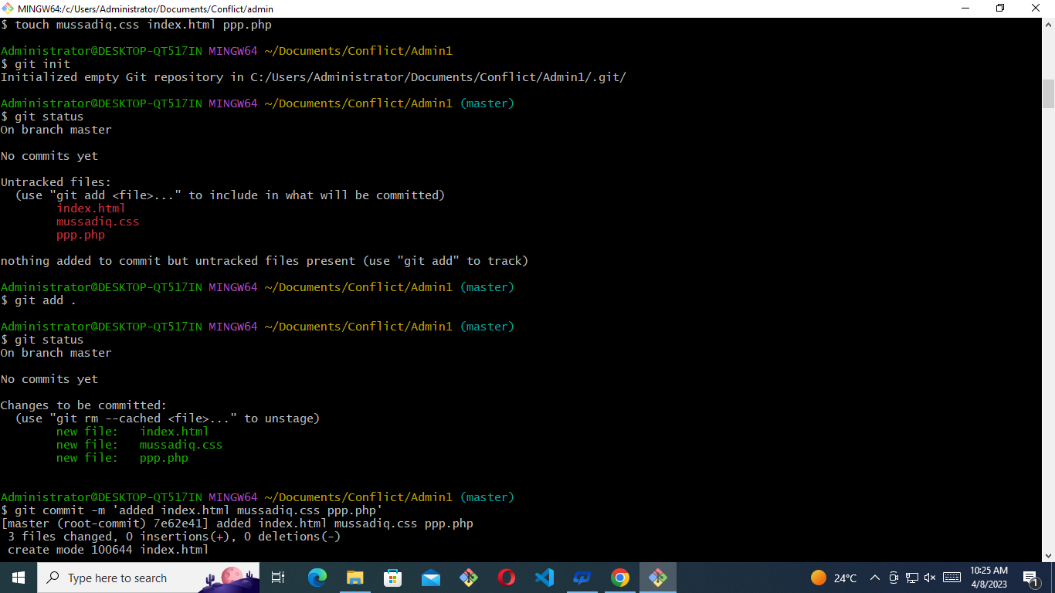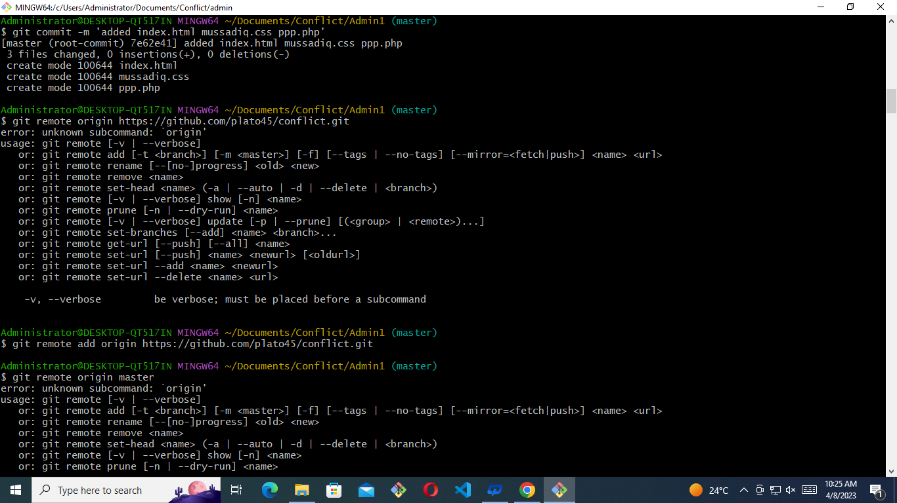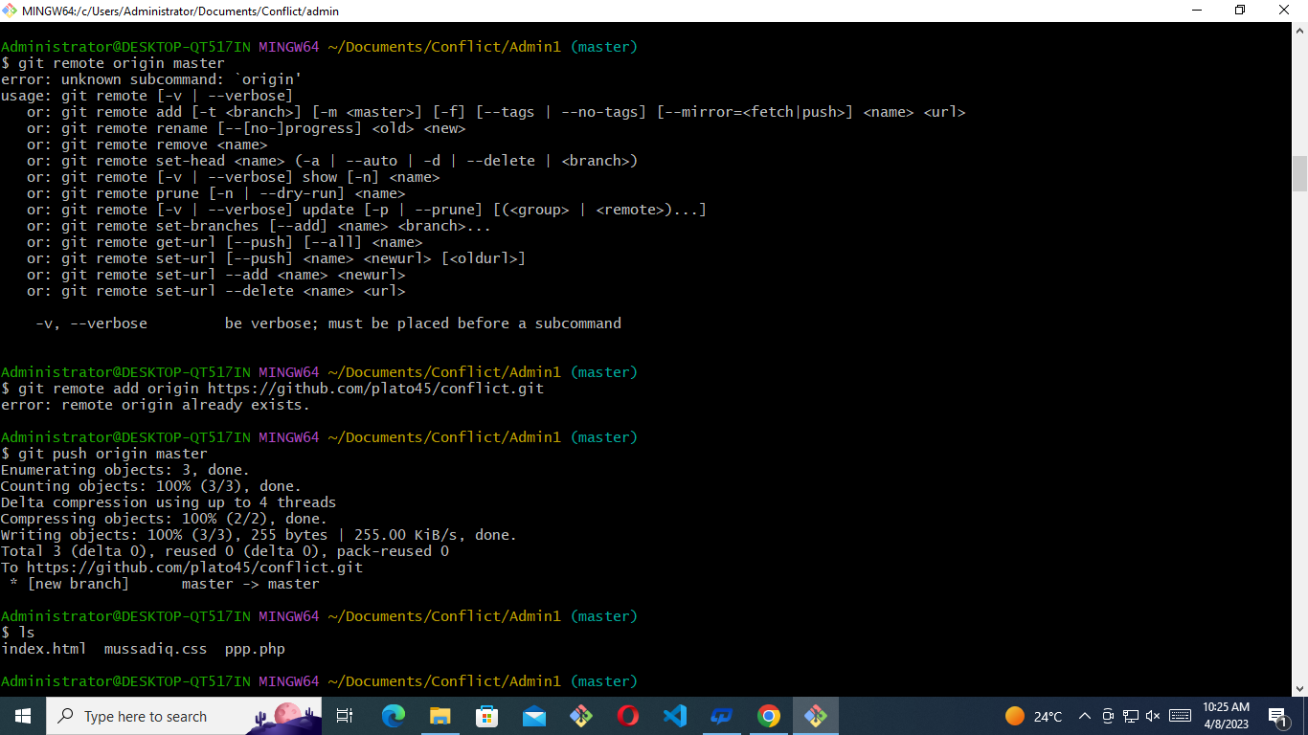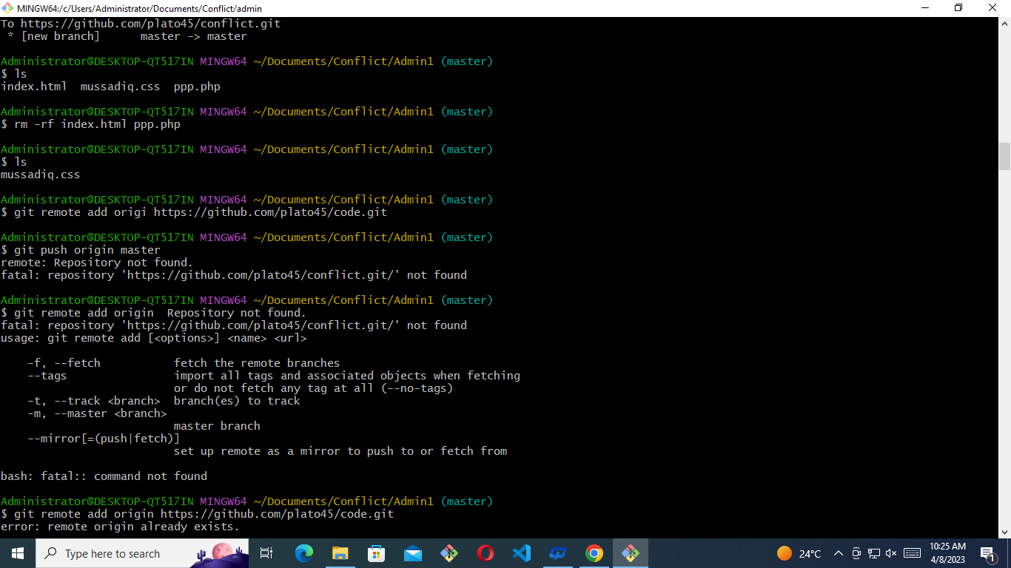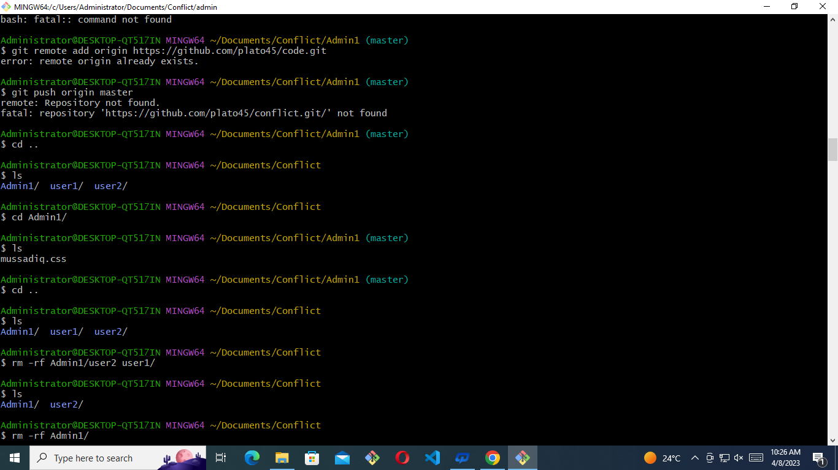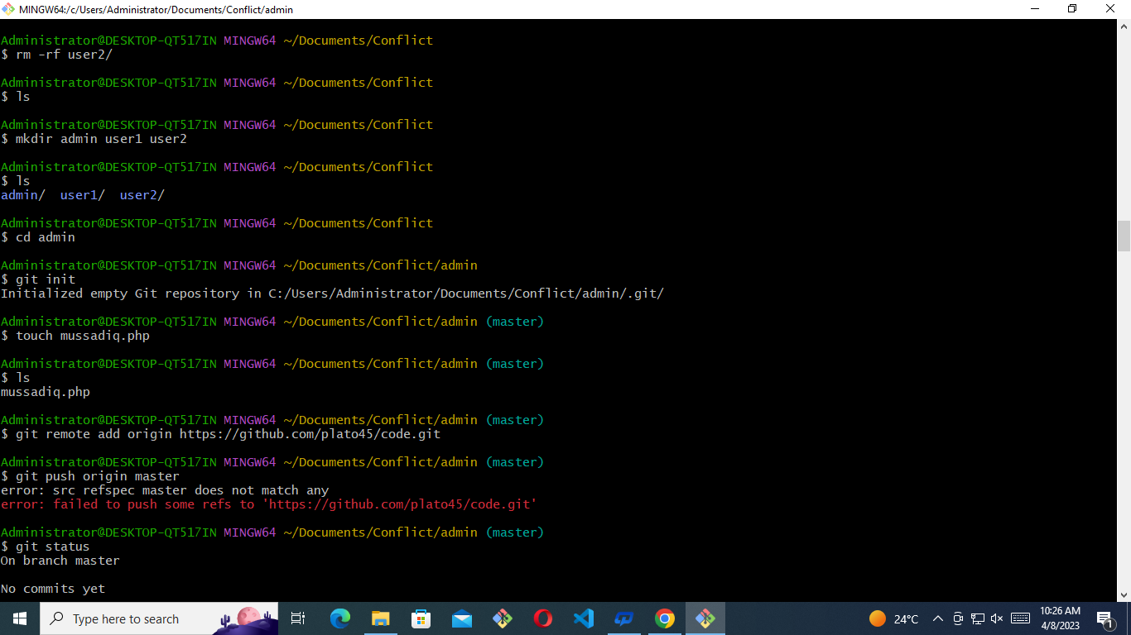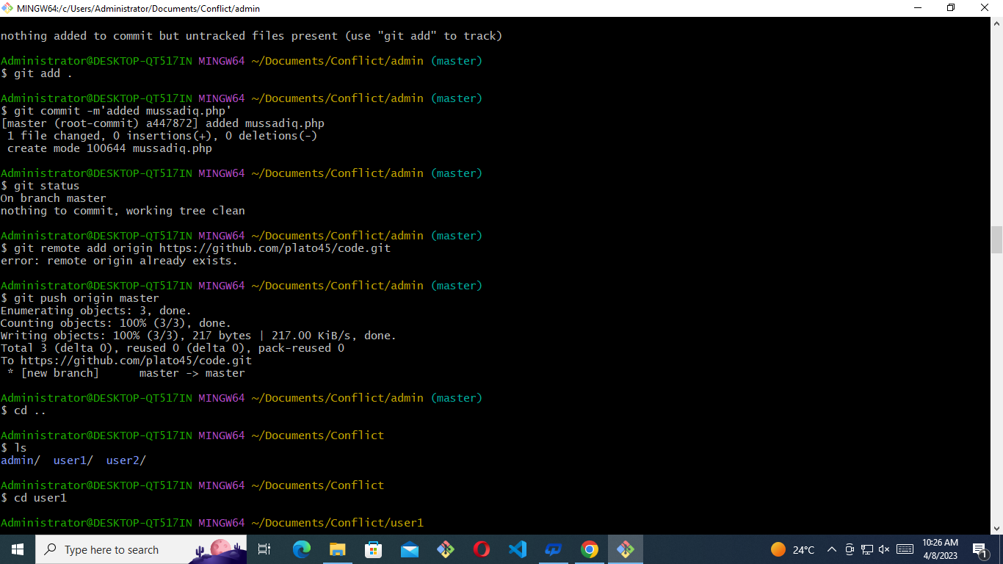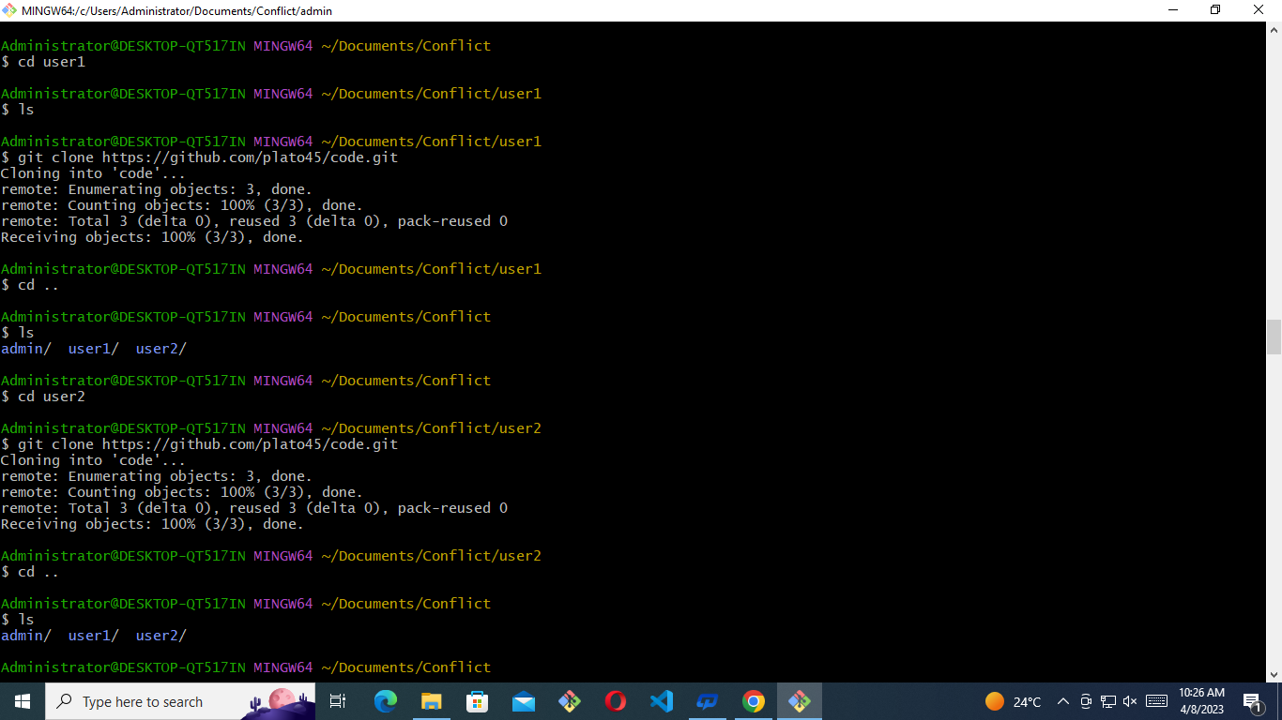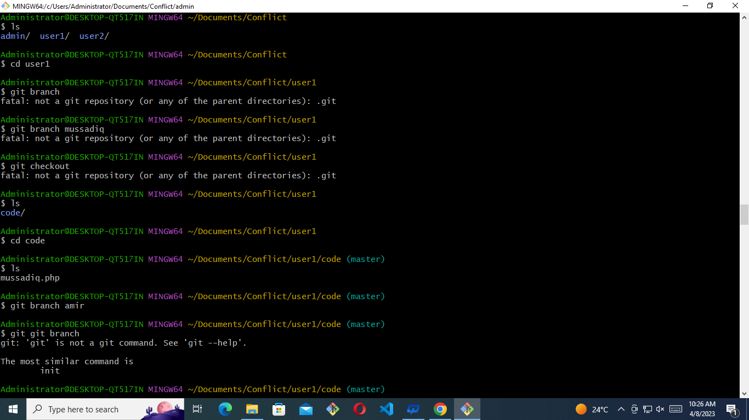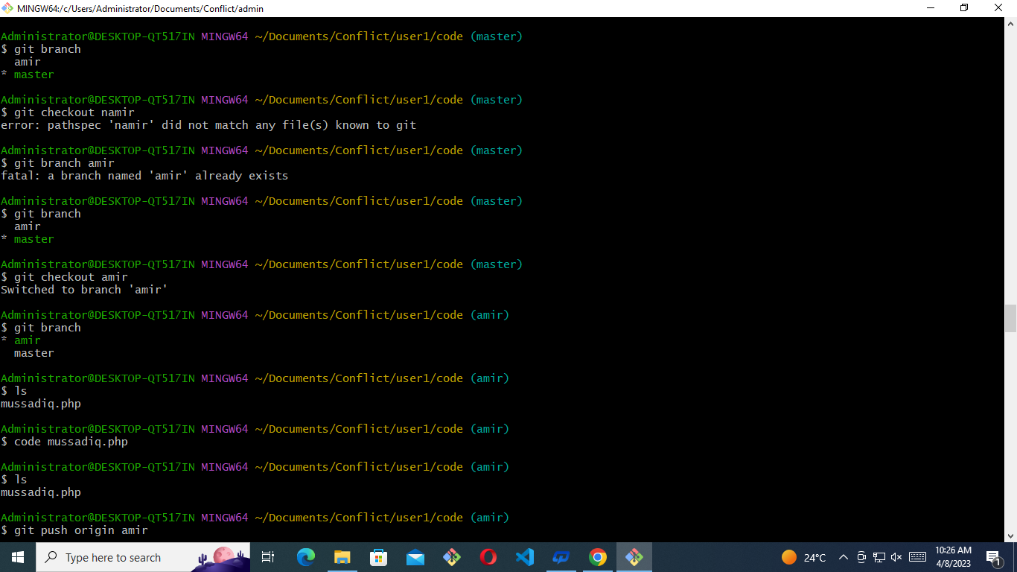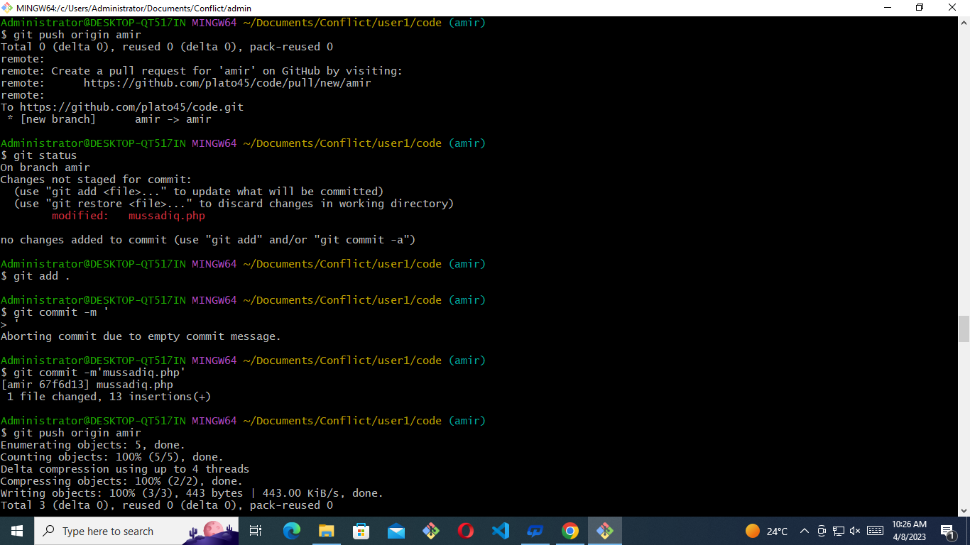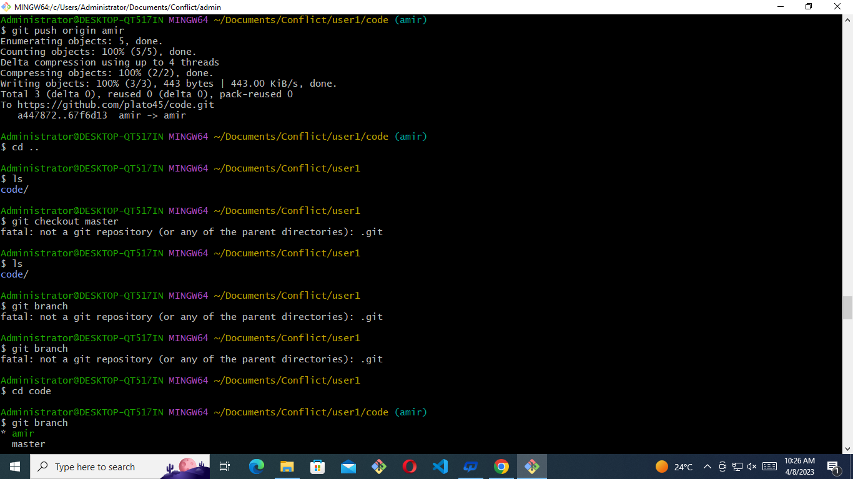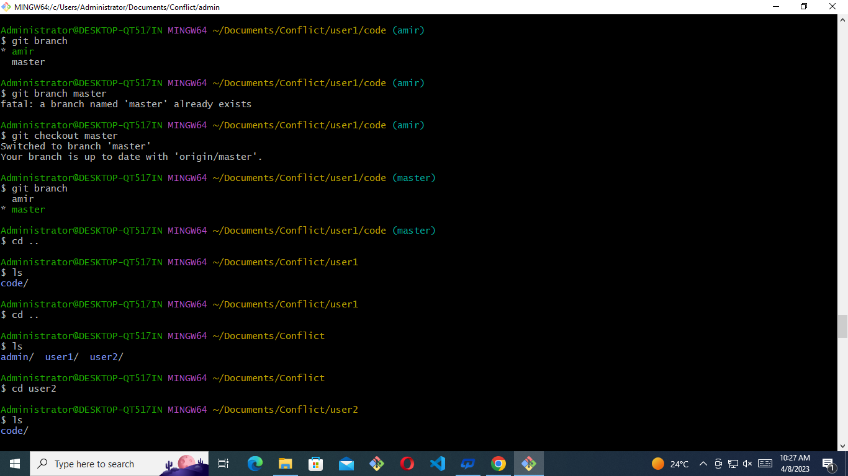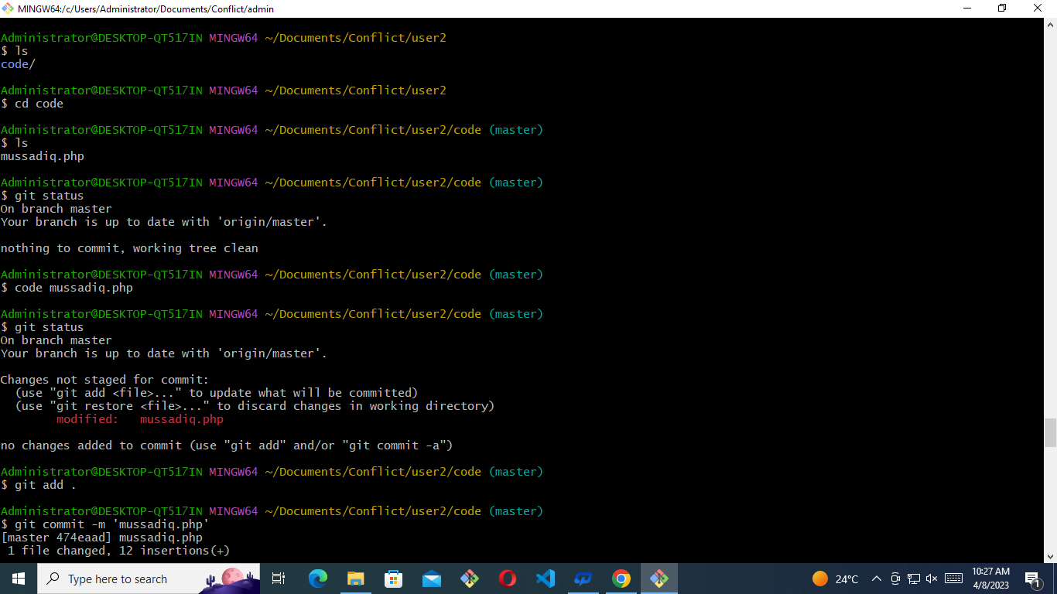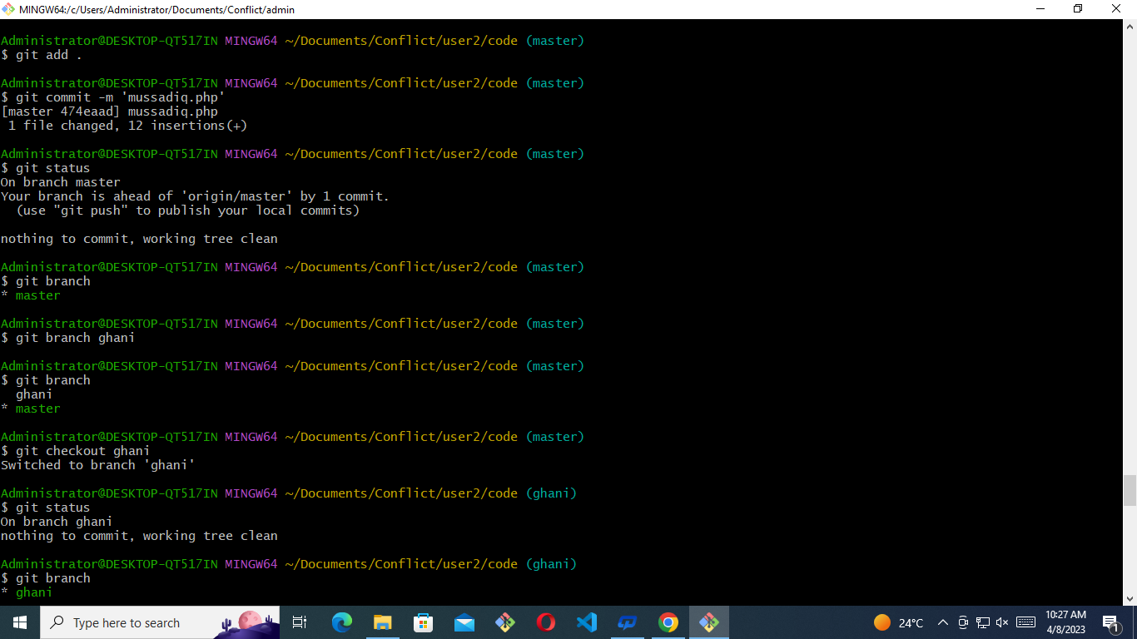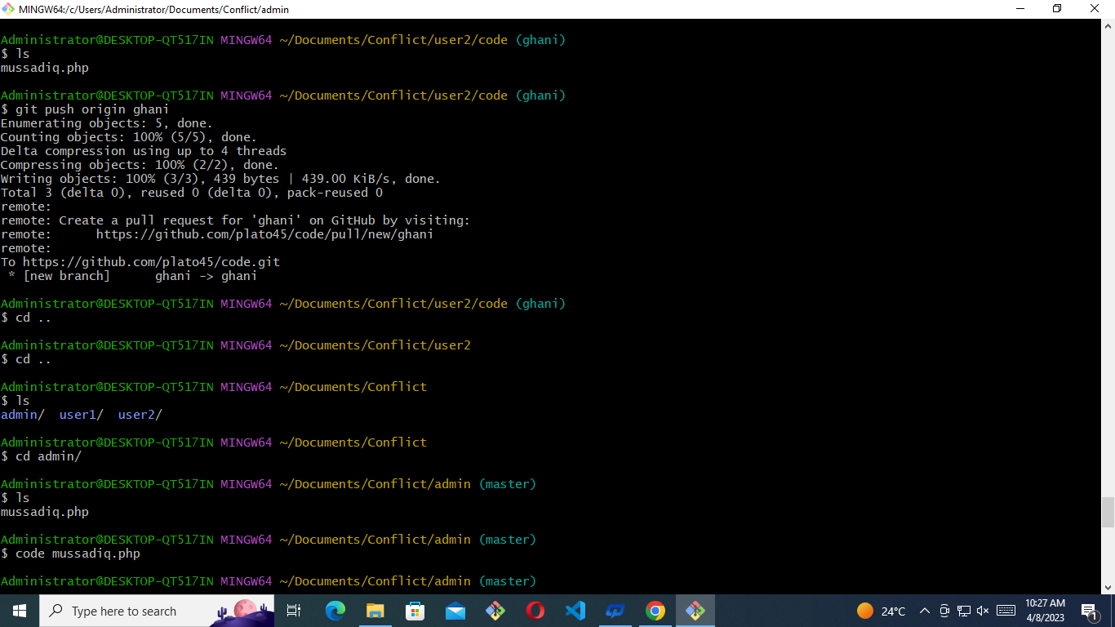
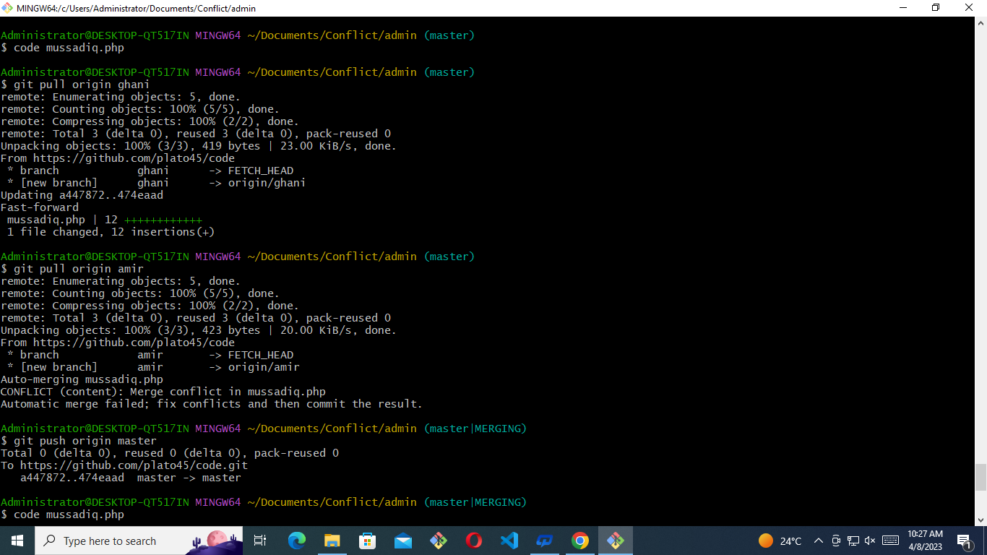
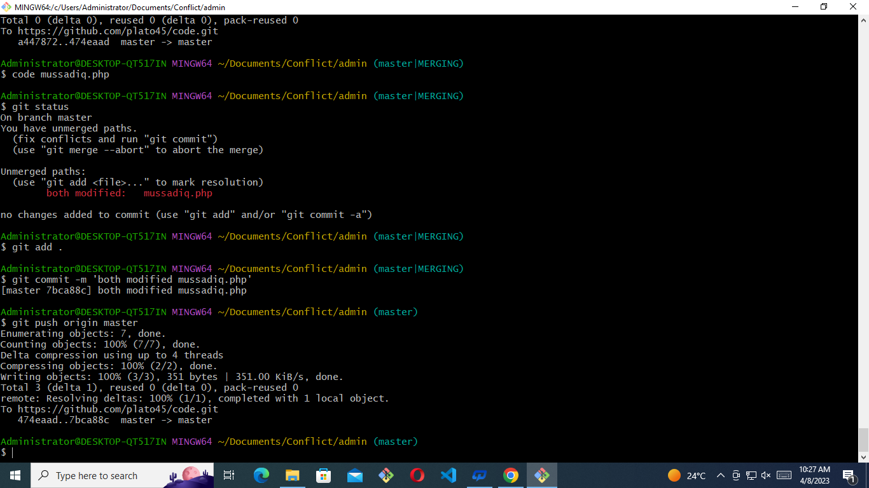

Administrator@DESKTOP-QT517IN MINGW64 ~/Documents/Conflict/admin (master)
$ pwd
/c/Users/Administrator/Documents/Conflict/admin

Administrator@DESKTOP-QT517IN MINGW64 ~/Documents/Conflict/admin (master)
$ ls
mussadiq.php

Administrator@DESKTOP-QT517IN MINGW64 ~/Documents/Conflict/admin (master)
$ cd ..

Administrator@DESKTOP-QT517IN MINGW64 ~/Documents/Conflict
$ cd ..

Administrator@DESKTOP-QT517IN MINGW64 ~/Documents
$ cd ..

Administrator@DESKTOP-QT517IN MINGW64 ~
$ ls
'3D Objects'/ IntelGraphicsProfiles/ NetHood@ Templates@
AppData/ Links/ OneDrive/ 'VS Class 1'/
'Application Data'@ 'Local Settings'@ Pictures/ Videos/
Contacts/ Music/ PrintHood@ ntuser.dat.LOG1
Cookies@ 'My Documents'@ Recent@ ntuser.dat.LOG2
Desktop/ NTUSER.DAT 'Saved Games'/ ntuser.ini
Documents/ NTUSER.DAT{53b39e88-18c4-11ea-a811-000d3aa4692b}.TM.blf Searches/
Downloads/ NTUSER.DAT{53b39e88-18c4-11ea-a811-000d3aa4692b}.TMContainer00000000000000000001.regtrans-ms SendTo@
Favorites/ NTUSER.DAT{53b39e88-18c4-11ea-a811-000d3aa4692b}.TMContainer00000000000000000002.regtrans-ms 'Start Menu'@

Administrator@DESKTOP-QT517IN MINGW64 ~
$ cd Documents/

Administrator@DESKTOP-QT517IN MINGW64 ~/Documents
$ ls
Conflict/ 'Custom Office Templates'/ 'My Music'@ 'My Pictures'@ 'My Videos'@ school/ ssh/ zarrar/

Administrator@DESKTOP-QT517IN MINGW64 ~/Documents
$ mkdir farhanconflict

Administrator@DESKTOP-QT517IN MINGW64 ~/Documents
$ ls
Conflict/ 'Custom Office Templates'/ 'My Music'@ 'My Pictures'@ 'My Videos'@ farhanconflict/ school/ ssh/ zarrar/

Administrator@DESKTOP-QT517IN MINGW64 ~/Documents
$ cd farhanconflict/

Administrator@DESKTOP-QT517IN MINGW64 ~/Documents/farhanconflict
$ touch iii.css

Administrator@DESKTOP-QT517IN MINGW64 ~/Documents/farhanconflict
$ ls
iii.css

Administrator@DESKTOP-QT517IN MINGW64 ~/Documents/farhanconflict
$ git init
Initialized empty Git repository in C:/Users/Administrator/Documents/farhanconflict/.git/

Administrator@DESKTOP-QT517IN MINGW64 ~/Documents/farhanconflict (master)
$ git status
On branch master

No commits yet

Untracked files:
(use "git add <file>..." to include in what will be committed)
iii.css

nothing added to commit but untracked files present (use "git add" to track)

Administrator@DESKTOP-QT517IN MINGW64 ~/Documents/farhanconflict (master)
$ git add .

Administrator@DESKTOP-QT517IN MINGW64 ~/Documents/farhanconflict (master)
$ git commit -m 'iii.css'
[master (root-commit) fc2e2f6] iii.css
1 file changed, 0 insertions(+), 0 deletions(-)
create mode 100644 iii.css

Administrator@DESKTOP-QT517IN MINGW64 ~/Documents/farhanconflict (master)
$ git status
On branch master
nothing to commit, working tree clean

Administrator@DESKTOP-QT517IN MINGW64 ~/Documents/farhanconflict (master)
$ git remote add origin https://github.com/plato45/usman.git

Administrator@DESKTOP-QT517IN MINGW64 ~/Documents/farhanconflict (master)
$ git push origin master
Enumerating objects: 3, done.
Counting objects: 100% (3/3), done.
Writing objects: 100% (3/3), 205 bytes | 205.00 KiB/s, done.
Total 3 (delta 0), reused 0 (delta 0), pack-reused 0
To https://github.com/plato45/usman.git
* [new branch] master -> master

Administrator@DESKTOP-QT517IN MINGW64 ~/Documents/farhanconflict (master)
$ cd ..

Administrator@DESKTOP-QT517IN MINGW64 ~/Documents
$ ls
Conflict/ 'Custom Office Templates'/ 'My Music'@ 'My Pictures'@ 'My Videos'@ farhanconflict/ school/ ssh/ zarrar/

Administrator@DESKTOP-QT517IN MINGW64 ~/Documents
$ cd dev1 dev2
bash: cd: too many arguments

Administrator@DESKTOP-QT517IN MINGW64 ~/Documents
$ mkdir dev1 dev2

Administrator@DESKTOP-QT517IN MINGW64 ~/Documents
$ ls
Conflict/ 'Custom Office Templates'/ 'My Music'@ 'My Pictures'@ 'My Videos'@ dev1/ dev2/ farhanconflict/ school/ ssh/ zarrar/

Administrator@DESKTOP-QT517IN MINGW64 ~/Documents
$ cd dev1

Administrator@DESKTOP-QT517IN MINGW64 ~/Documents/dev1
$ git clone https://github.com/plato45/usman.git
Cloning into 'usman'...
remote: Enumerating objects: 3, done.
remote: Counting objects: 100% (3/3), done.
remote: Total 3 (delta 0), reused 3 (delta 0), pack-reused 0
Receiving objects: 100% (3/3), done.

Administrator@DESKTOP-QT517IN MINGW64 ~/Documents/dev1
$ cd ..

Administrator@DESKTOP-QT517IN MINGW64 ~/Documents
$ cd dev2

Administrator@DESKTOP-QT517IN MINGW64 ~/Documents/dev2
$ ls

Administrator@DESKTOP-QT517IN MINGW64 ~/Documents/dev2
$ git clone https://github.com/plato45/usman.git
Cloning into 'usman'...
remote: Enumerating objects: 3, done.
remote: Counting objects: 100% (3/3), done.
remote: Total 3 (delta 0), reused 3 (delta 0), pack-reused 0
Receiving objects: 100% (3/3), done.

Administrator@DESKTOP-QT517IN MINGW64 ~/Documents/dev2
$ cd ..

Administrator@DESKTOP-QT517IN MINGW64 ~/Documents
$ cd dev1

Administrator@DESKTOP-QT517IN MINGW64 ~/Documents/dev1
$ ls
usman/

Administrator@DESKTOP-QT517IN MINGW64 ~/Documents/dev1
$ cd usman

Administrator@DESKTOP-QT517IN MINGW64 ~/Documents/dev1/usman (master)
$ ls
iii.css

Administrator@DESKTOP-QT517IN MINGW64 ~/Documents/dev1/usman (master)
$ code iii.css

Administrator@DESKTOP-QT517IN MINGW64 ~/Documents/dev1/usman (master)
$ cd ..

Administrator@DESKTOP-QT517IN MINGW64 ~/Documents/dev1
$ cd ..

Administrator@DESKTOP-QT517IN MINGW64 ~/Documents
$ cd ..

Administrator@DESKTOP-QT517IN MINGW64 ~
$ ls
'3D Objects'/ IntelGraphicsProfiles/ NetHood@ Templates@
AppData/ Links/ OneDrive/ 'VS Class 1'/
'Application Data'@ 'Local Settings'@ Pictures/ Videos/
Contacts/ Music/ PrintHood@ ntuser.dat.LOG1
Cookies@ 'My Documents'@ Recent@ ntuser.dat.LOG2
Desktop/ NTUSER.DAT 'Saved Games'/ ntuser.ini
Documents/ NTUSER.DAT{53b39e88-18c4-11ea-a811-000d3aa4692b}.TM.blf Searches/
Downloads/ NTUSER.DAT{53b39e88-18c4-11ea-a811-000d3aa4692b}.TMContainer00000000000000000001.regtrans-ms SendTo@
Favorites/ NTUSER.DAT{53b39e88-18c4-11ea-a811-000d3aa4692b}.TMContainer00000000000000000002.regtrans-ms 'Start Menu'@

Administrator@DESKTOP-QT517IN MINGW64 ~
$ cd Documents/

Administrator@DESKTOP-QT517IN MINGW64 ~/Documents
$ ls
Conflict/ 'Custom Office Templates'/ 'My Music'@ 'My Pictures'@ 'My Videos'@ dev1/ dev2/ farhanconflict/ school/ ssh/ zarrar/

Administrator@DESKTOP-QT517IN MINGW64 ~/Documents
$ rm -rf farhanconflict/

Administrator@DESKTOP-QT517IN MINGW64 ~/Documents
$ rm -rf dev1

Administrator@DESKTOP-QT517IN MINGW64 ~/Documents
$ rm -rf dev2

Administrator@DESKTOP-QT517IN MINGW64 ~/Documents
$ ls
Conflict/ 'Custom Office Templates'/ 'My Music'@ 'My Pictures'@ 'My Videos'@ school/ ssh/ zarrar/

Administrator@DESKTOP-QT517IN MINGW64 ~/Documents
$ mkdir farhan dev1 dev2

Administrator@DESKTOP-QT517IN MINGW64 ~/Documents
$ ls
Conflict/ 'Custom Office Templates'/ 'My Music'@ 'My Pictures'@ 'My Videos'@ dev1/ dev2/ farhan/ school/ ssh/ zarrar/

Administrator@DESKTOP-QT517IN MINGW64 ~/Documents
$ cd farhan/

Administrator@DESKTOP-QT517IN MINGW64 ~/Documents/farhan
$ touch iii.html

Administrator@DESKTOP-QT517IN MINGW64 ~/Documents/farhan
$ git init
Initialized empty Git repository in C:/Users/Administrator/Documents/farhan/.git/

Administrator@DESKTOP-QT517IN MINGW64 ~/Documents/farhan (master)
$ git add .

Administrator@DESKTOP-QT517IN MINGW64 ~/Documents/farhan (master)
$ git commit -m 'iii.html'
[master (root-commit) 822e934] iii.html
1 file changed, 0 insertions(+), 0 deletions(-)
create mode 100644 iii.html

Administrator@DESKTOP-QT517IN MINGW64 ~/Documents/farhan (master)
$ git remote add origin https://github.com/plato45/balahaton.git

Administrator@DESKTOP-QT517IN MINGW64 ~/Documents/farhan (master)
$ git push origin master
Enumerating objects: 3, done.
Counting objects: 100% (3/3), done.
Writing objects: 100% (3/3), 208 bytes | 208.00 KiB/s, done.
Total 3 (delta 0), reused 0 (delta 0), pack-reused 0
To https://github.com/plato45/balahaton.git
* [new branch] master -> master

Administrator@DESKTOP-QT517IN MINGW64 ~/Documents/farhan (master)
$ cd ..

Administrator@DESKTOP-QT517IN MINGW64 ~/Documents
$ cd dev1

Administrator@DESKTOP-QT517IN MINGW64 ~/Documents/dev1
$ git clone https://github.com/plato45/balahaton.git
Cloning into 'balahaton'...
cdremote: Enumerating objects: 3, done.
remote: Counting objects: 100% (3/3), done.
remote: Total 3 (delta 0), reused 3 (delta 0), pack-reused 0
Receiving objects: 100% (3/3), done.

Administrator@DESKTOP-QT517IN MINGW64 ~/Documents/dev1
$ cd ..

Administrator@DESKTOP-QT517IN MINGW64 ~/Documents
$ cd dev2

Administrator@DESKTOP-QT517IN MINGW64 ~/Documents/dev2
$ ls

Administrator@DESKTOP-QT517IN MINGW64 ~/Documents/dev2
$ git clone https://github.com/plato45/balahaton.git
Cloning into 'balahaton'...
remote: Enumerating objects: 3, done.
remote: Counting objects: 100% (3/3), done.
remote: Total 3 (delta 0), reused 3 (delta 0), pack-reused 0
Receiving objects: 100% (3/3), done.

Administrator@DESKTOP-QT517IN MINGW64 ~/Documents/dev2
$ cd ..

Administrator@DESKTOP-QT517IN MINGW64 ~/Documents
$ cd ..

Administrator@DESKTOP-QT517IN MINGW64 ~
$ cd dev2
bash: cd: dev2: No such file or directory

Administrator@DESKTOP-QT517IN MINGW64 ~
$ cd dev1
bash: cd: dev1: No such file or directory

Administrator@DESKTOP-QT517IN MINGW64 ~
$ ls
'3D Objects'/ IntelGraphicsProfiles/ NetHood@ Templates@
AppData/ Links/ OneDrive/ 'VS Class 1'/
'Application Data'@ 'Local Settings'@ Pictures/ Videos/
Contacts/ Music/ PrintHood@ ntuser.dat.LOG1
Cookies@ 'My Documents'@ Recent@ ntuser.dat.LOG2
Desktop/ NTUSER.DAT 'Saved Games'/ ntuser.ini
Documents/ NTUSER.DAT{53b39e88-18c4-11ea-a811-000d3aa4692b}.TM.blf Searches/
Downloads/ NTUSER.DAT{53b39e88-18c4-11ea-a811-000d3aa4692b}.TMContainer00000000000000000001.regtrans-ms SendTo@
Favorites/ NTUSER.DAT{53b39e88-18c4-11ea-a811-000d3aa4692b}.TMContainer00000000000000000002.regtrans-ms 'Start Menu'@

Administrator@DESKTOP-QT517IN MINGW64 ~
$ cd Documents/

Administrator@DESKTOP-QT517IN MINGW64 ~/Documents
$ ls
Conflict/ 'Custom Office Templates'/ 'My Music'@ 'My Pictures'@ 'My Videos'@ dev1/ dev2/ farhan/ school/ ssh/ zarrar/

Administrator@DESKTOP-QT517IN MINGW64 ~/Documents
$ cd dev1

Administrator@DESKTOP-QT517IN MINGW64 ~/Documents/dev1
$ ls
balahaton/

Administrator@DESKTOP-QT517IN MINGW64 ~/Documents/dev1
$ cd ..

Administrator@DESKTOP-QT517IN MINGW64 ~/Documents
$ cd dev2

Administrator@DESKTOP-QT517IN MINGW64 ~/Documents/dev2
$ ls
balahaton/

Administrator@DESKTOP-QT517IN MINGW64 ~/Documents/dev2
$ cd ..

Administrator@DESKTOP-QT517IN MINGW64 ~/Documents
$ cd dev1

Administrator@DESKTOP-QT517IN MINGW64 ~/Documents/dev1
$ ls
balahaton/

Administrator@DESKTOP-QT517IN MINGW64 ~/Documents/dev1
$ cd balahaton/

Administrator@DESKTOP-QT517IN MINGW64 ~/Documents/dev1/balahaton (master)
$ ls
iii.html

Administrator@DESKTOP-QT517IN MINGW64 ~/Documents/dev1/balahaton (master)
$ code iii.html

Administrator@DESKTOP-QT517IN MINGW64 ~/Documents/dev1/balahaton (master)
$ git status
On branch master
Your branch is up to date with 'origin/master'.

Changes not staged for commit:
(use "git add <file>..." to update what will be committed)
(use "git restore <file>..." to discard changes in working directory)
modified: iii.html

no changes added to commit (use "git add" and/or "git commit -a")

Administrator@DESKTOP-QT517IN MINGW64 ~/Documents/dev1/balahaton (master)
$ git add .

Administrator@DESKTOP-QT517IN MINGW64 ~/Documents/dev1/balahaton (master)
$ git commit -m 'iii.html'
[master f2d25e5] iii.html
1 file changed, 12 insertions(+)

Administrator@DESKTOP-QT517IN MINGW64 ~/Documents/dev1/balahaton (master)
$ git branch
* master

Administrator@DESKTOP-QT517IN MINGW64 ~/Documents/dev1/balahaton (master)
$ git branch orhan

Administrator@DESKTOP-QT517IN MINGW64 ~/Documents/dev1/balahaton (master)
$ git branch
* master
orhan

Administrator@DESKTOP-QT517IN MINGW64 ~/Documents/dev1/balahaton (master)
$ git checkout orhan
Switched to branch 'orhan'

Administrator@DESKTOP-QT517IN MINGW64 ~/Documents/dev1/balahaton (orhan)
$ git push origin orhan
Enumerating objects: 5, done.
Counting objects: 100% (5/5), done.
Delta compression using up to 4 threads
Compressing objects: 100% (2/2), done.
Writing objects: 100% (3/3), 434 bytes | 434.00 KiB/s, done.
Total 3 (delta 0), reused 0 (delta 0), pack-reused 0
remote:
remote: Create a pull request for 'orhan' on GitHub by visiting:
remote: https://github.com/plato45/balahaton/pull/new/orhan
remote:
To https://github.com/plato45/balahaton.git
* [new branch] orhan -> orhan

Administrator@DESKTOP-QT517IN MINGW64 ~/Documents/dev1/balahaton (orhan)
$ cd ..

Administrator@DESKTOP-QT517IN MINGW64 ~/Documents/dev1
$ git checkout master
fatal: not a git repository (or any of the parent directories): .git

Administrator@DESKTOP-QT517IN MINGW64 ~/Documents/dev1
$ cd ..

Administrator@DESKTOP-QT517IN MINGW64 ~/Documents
$ cd ..

Administrator@DESKTOP-QT517IN MINGW64 ~
$ cd dev2
bash: cd: dev2: No such file or directory

Administrator@DESKTOP-QT517IN MINGW64 ~
$ cd Documents/

Administrator@DESKTOP-QT517IN MINGW64 ~/Documents
$ cd dev2

Administrator@DESKTOP-QT517IN MINGW64 ~/Documents/dev2
$ ls
balahaton/

Administrator@DESKTOP-QT517IN MINGW64 ~/Documents/dev2
$ cd balahaton/

Administrator@DESKTOP-QT517IN MINGW64 ~/Documents/dev2/balahaton (master)
$ ls
iii.html

Administrator@DESKTOP-QT517IN MINGW64 ~/Documents/dev2/balahaton (master)
$ code iii.html

Administrator@DESKTOP-QT517IN MINGW64 ~/Documents/dev2/balahaton (master)
$ git status
On branch master
Your branch is up to date with 'origin/master'.

Changes not staged for commit:
(use "git add <file>..." to update what will be committed)
(use "git restore <file>..." to discard changes in working directory)
modified: iii.html

no changes added to commit (use "git add" and/or "git commit -a")

Administrator@DESKTOP-QT517IN MINGW64 ~/Documents/dev2/balahaton (master)
$ git add .

Administrator@DESKTOP-QT517IN MINGW64 ~/Documents/dev2/balahaton (master)
$ git commit -m 'iii.html'
[master 7603470] iii.html
1 file changed, 12 insertions(+)

Administrator@DESKTOP-QT517IN MINGW64 ~/Documents/dev2/balahaton (master)
$ git branch
* master

Administrator@DESKTOP-QT517IN MINGW64 ~/Documents/dev2/balahaton (master)
$ git branch malhun

Administrator@DESKTOP-QT517IN MINGW64 ~/Documents/dev2/balahaton (master)
$ git branch
malhun
* master

Administrator@DESKTOP-QT517IN MINGW64 ~/Documents/dev2/balahaton (master)
$ git checkout malhun
Switched to branch 'malhun'

Administrator@DESKTOP-QT517IN MINGW64 ~/Documents/dev2/balahaton (malhun)
$ git branch
* malhun
master

Administrator@DESKTOP-QT517IN MINGW64 ~/Documents/dev2/balahaton (malhun)
$ ls
iii.html

Administrator@DESKTOP-QT517IN MINGW64 ~/Documents/dev2/balahaton (malhun)
$ git push origin malhun
Enumerating objects: 5, done.
Counting objects: 100% (5/5), done.
Delta compression using up to 4 threads
Compressing objects: 100% (2/2), done.
Writing objects: 100% (3/3), 431 bytes | 431.00 KiB/s, done.
Total 3 (delta 0), reused 0 (delta 0), pack-reused 0
remote:
remote: Create a pull request for 'malhun' on GitHub by visiting:
remote: https://github.com/plato45/balahaton/pull/new/malhun
remote:
To https://github.com/plato45/balahaton.git
* [new branch] malhun -> malhun

Administrator@DESKTOP-QT517IN MINGW64 ~/Documents/dev2/balahaton (malhun)
$ cd ..

Administrator@DESKTOP-QT517IN MINGW64 ~/Documents/dev2
$ ls
balahaton/

Administrator@DESKTOP-QT517IN MINGW64 ~/Documents/dev2
$ cd .

Administrator@DESKTOP-QT517IN MINGW64 ~/Documents/dev2
$ cd ..

Administrator@DESKTOP-QT517IN MINGW64 ~/Documents
$ ls
Conflict/ 'Custom Office Templates'/ 'My Music'@ 'My Pictures'@ 'My Videos'@ dev1/ dev2/ farhan/ school/ ssh/ zarrar/

Administrator@DESKTOP-QT517IN MINGW64 ~/Documents
$ cd farhan/

Administrator@DESKTOP-QT517IN MINGW64 ~/Documents/farhan (master)
$ ls
iii.html

Administrator@DESKTOP-QT517IN MINGW64 ~/Documents/farhan (master)
$ git pull origin orhan
remote: Enumerating objects: 5, done.
remote: Counting objects: 100% (5/5), done.
remote: Compressing objects: 100% (2/2), done.
remote: Total 3 (delta 0), reused 3 (delta 0), pack-reused 0
Unpacking objects: 100% (3/3), 414 bytes | 15.00 KiB/s, done.
From https://github.com/plato45/balahaton
* branch orhan -> FETCH_HEAD
* [new branch] orhan -> origin/orhan
Updating 822e934..f2d25e5
Fast-forward
iii.html | 12 ++++++++++++
1 file changed, 12 insertions(+)

Administrator@DESKTOP-QT517IN MINGW64 ~/Documents/farhan (master)
$ git pull origin malhun
remote: Enumerating objects: 5, done.
remote: Counting objects: 100% (5/5), done.
remote: Compressing objects: 100% (2/2), done.
remote: Total 3 (delta 0), reused 3 (delta 0), pack-reused 0
Unpacking objects: 100% (3/3), 411 bytes | 15.00 KiB/s, done.
From https://github.com/plato45/balahaton
* branch malhun -> FETCH_HEAD
* [new branch] malhun -> origin/malhun
Auto-merging iii.html
CONFLICT (content): Merge conflict in iii.html
Automatic merge failed; fix conflicts and then commit the result.

Administrator@DESKTOP-QT517IN MINGW64 ~/Documents/farhan (master|MERGING)
$ git push origin master
Total 0 (delta 0), reused 0 (delta 0), pack-reused 0
To https://github.com/plato45/balahaton.git
822e934..f2d25e5 master -> master

Administrator@DESKTOP-QT517IN MINGW64 ~/Documents/farhan (master|MERGING)
$ code iii.html

Administrator@DESKTOP-QT517IN MINGW64 ~/Documents/farhan (master|MERGING)
$ git push origin master
Everything up-to-date

Administrator@DESKTOP-QT517IN MINGW64 ~/Documents/farhan (master|MERGING)
$ git status
On branch master
You have unmerged paths.
(fix conflicts and run "git commit")
(use "git merge --abort" to abort the merge)

Unmerged paths:
(use "git add <file>..." to mark resolution)
both modified: iii.html

no changes added to commit (use "git add" and/or "git commit -a")

Administrator@DESKTOP-QT517IN MINGW64 ~/Documents/farhan (master|MERGING)
$ git add .

Administrator@DESKTOP-QT517IN MINGW64 ~/Documents/farhan (master|MERGING)
$ git commit -m "iii.html"
[master 947cda2] iii.html

Administrator@DESKTOP-QT517IN MINGW64 ~/Documents/farhan (master)
$ git push origin master
Enumerating objects: 7, done.
Counting objects: 100% (7/7), done.
Delta compression using up to 4 threads
Compressing objects: 100% (2/2), done.
Writing objects: 100% (3/3), 341 bytes | 341.00 KiB/s, done.
Total 3 (delta 1), reused 0 (delta 0), pack-reused 0
remote: Resolving deltas: 100% (1/1), completed with 1 local object.
To https://github.com/plato45/balahaton.git
f2d25e5..947cda2 master -> master

Administrator@DESKTOP-QT517IN MINGW64 ~/Documents/farhan (master)
$
